A

PROJECT REPORT

ON

**Book Recommendation Chatbot**

**Using**

**IBM Watson Assistant**

Submitted by: Ayush raj

Vivekananda Global University, Jaipur

TABLE OF CONTENTS

INTRODUCTION 3

TOOLS USED 4

SET UP PROCESS 5

CONFIGURATION 6

DESIGNING THE CHATBOT 7

INTENTS 7

ENTITIES 8

DIALOG 9

HOW WEBSITE LOOK 14

RESULTS 15

REFERENCE 20

# INTRODUCTION

This project aims to design a **conversational chatbot using IBM Watson Assistant** to recommend books based on **user interests** such as genre, author, and mood. The chatbot engages users in natural conversation, captures their preferences, and provides personalized book suggestions efficiently. It can be integrated into websites or mobile applications to enhance user engagement for libraries, bookshops, or reading communities.

# TOOLS USED

* **IBM Watson Assistant**: To create, train, and deploy the conversational chatbot.
* **IBM Cloud**: To host Watson Assistant and manage resources.
* **JSON / CSV**: For managing intents, entities, and dialog flows during upload.
* **Google Sheets / Excel**: For preparing entity and intent training data.
* **Slack / Web Widget**: For testing and deploying the chatbot interface.

# SET UP PROCESS

1. **Create IBM Cloud Account:**

Sign up on [IBM Cloud](https://cloud.ibm.com/).

Navigate to Watson Assistant and create a new instance.

1. **Create Assistant:**

Go to Watson Assistant, create a new Assistant project (e.g., “BookBuddy”).

1. **Create Skill:**

Add a Dialog Skill to your Assistant.

1. **Workspace Structure:**

Define Intents (e.g., #book_recommendation, #greet, #goodbye).

Create Entities (e.g., @genre, @author, @mood).

Develop Dialog Flows for conversation logic.

1. **Integrate and Test:**

Connect the Assistant to a web widget or Slack for live testing.

Train and iterate based on conversation testing.

# CONFIGURATION

* Enable dialog from Assistant setting to on the dialog menu
* Created 6 intents to train the chatbot with intent capturing user goal.

#greet

#goodbye

#provide_author

#provide_genre

#provide_mood

#recommend _book

#thanks

* Created entities to capture specific user preferences:

@genre , @author, @mood

* Created dialog with root node and child node to train the chatbot and understand that what to respond to user’s prompts
* Customized web chat in it we customised the chatbot how it look.

# DESIGNING THE CHATBOT

INTENTS: Intents are a collection of user statements that have the same meaning. By creating intents the assistant is trained to understand the variety of ways users express their goals.

| **Intent Name** | **Example User Utterances** |
| --- | --- |
| #greet | Hi, hello, hey |
| #goodbye | Bye, see you, exit |
| #recommend_book | Recommend me a book, suggest a book, I want a book |
| #provide_genre | I like fantasy, do you have mystery, romance books |
| #provide_author | Books by Agatha Christie, I like Dan Brown |
| #provide_mood | I feel sad, need something uplifting, want something dark |
| #thanks | Thanks, thank you |

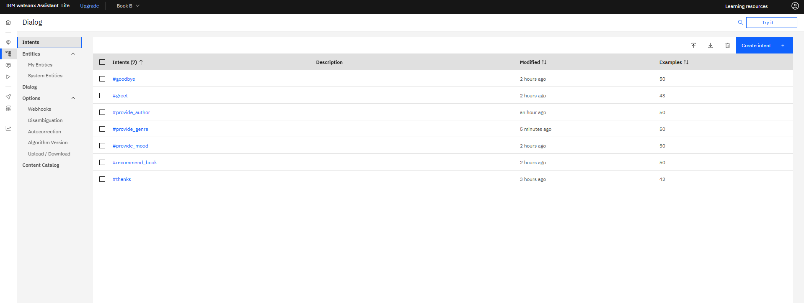

## ENTITIES

Create entities to capture *key variables*:

**Entities:**

* @genre (e.g., fantasy, mystery, romance, sci-fi)
* @author (Dan Brown, Agatha Christie, etc.)
* @mood (happy, sad, dark, light, uplifting)

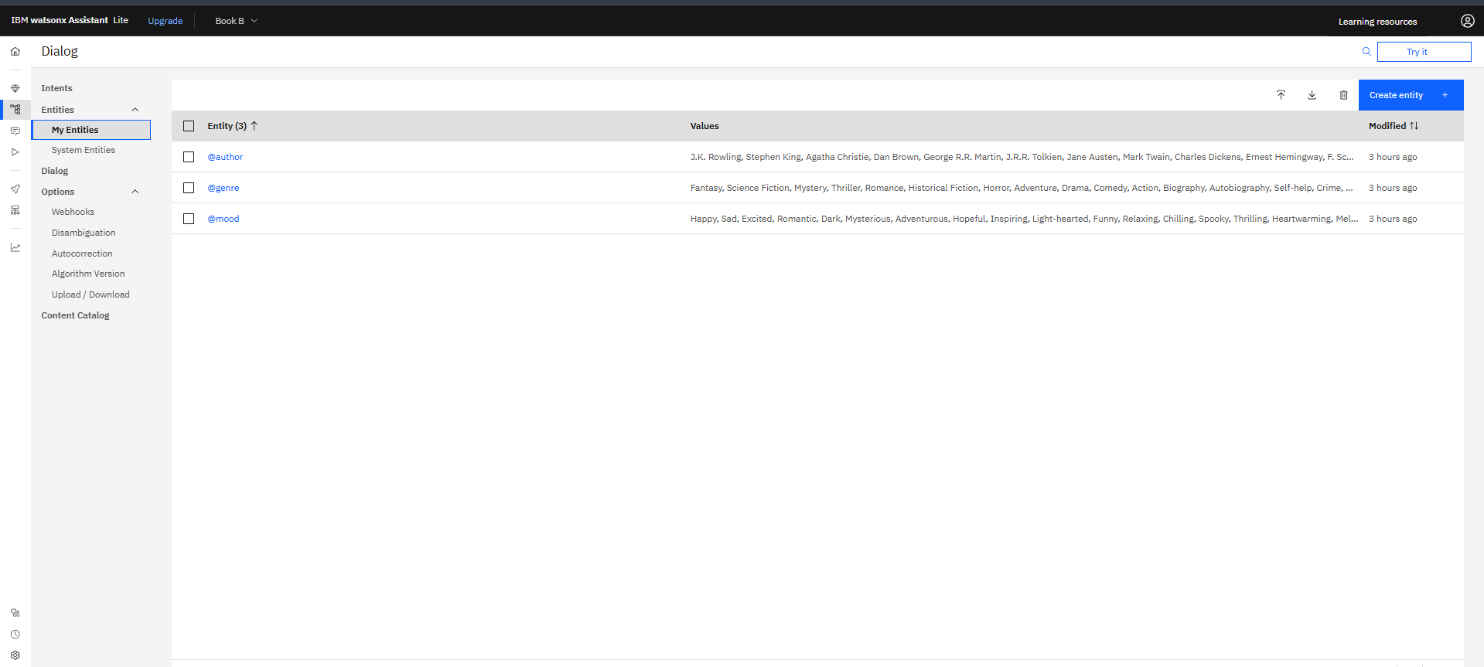

DIALOG-- The part of your chatbot that controls how it *talks to users*, decides *what to say*, and manages *the conversation flow*.

* WELCOME NODE (#GREET)

what it *does*:

* listens for greetings like “hi”, “hello”, “hey”.
* when triggered:
  + greets the user warmly.
  + introduces the bot’s purpose
* RECOMMEND BOOK NODE (#RECOMMEND_BOOK)

what it *does*:

* listens when the user explicitly asks for a recommendation, e.g.:
  + “can you recommend a book?”
  + “suggest me something to read.”
  + “i want a book recommendation.”
* when triggered:
  + acknowledges the user’s request.
  + prompts them to specify *genre, author, or mood*.
* PROVIDE GENRE NODE (#PROVIDE_GENRE)

what it *does*:

* listens when the user mentions a genre the bot recognizes, e.g.:
  + “i like mystery.”
  + “suggest a fantasy book.”
  + “i want a romance novel.”
* PROVIDE AUTHOR NODE (#PROVIDE_AUTHOR)

what it *does*:

* listens when the user mentions an author, e.g.:
  + “i like dan brown.”
  + “books by agatha christie.”
* THANKS NODE (#THANKS)

what it *does*:

* listens when the user says “thanks”, “thank you”.
* responds:

“you’re welcome! happy reading!”

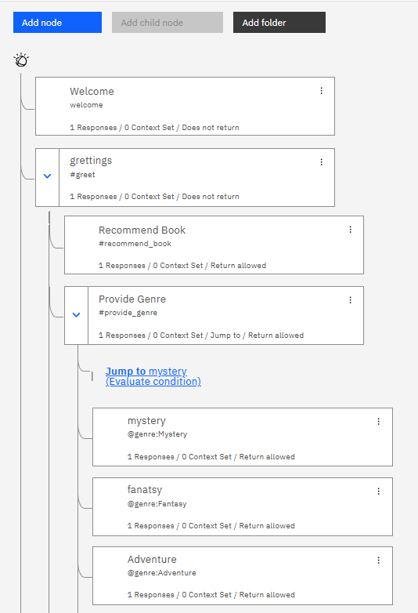

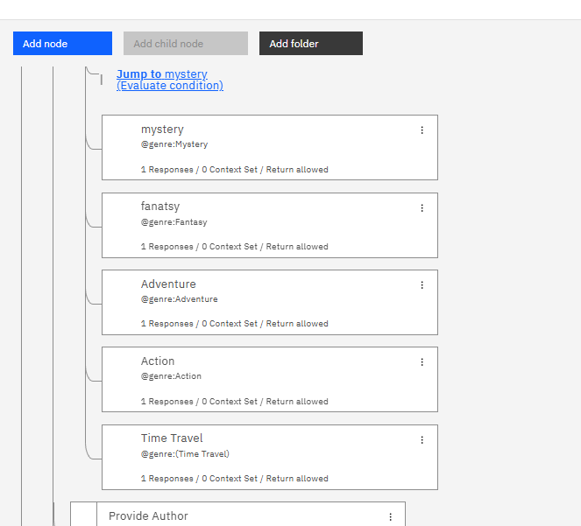

.

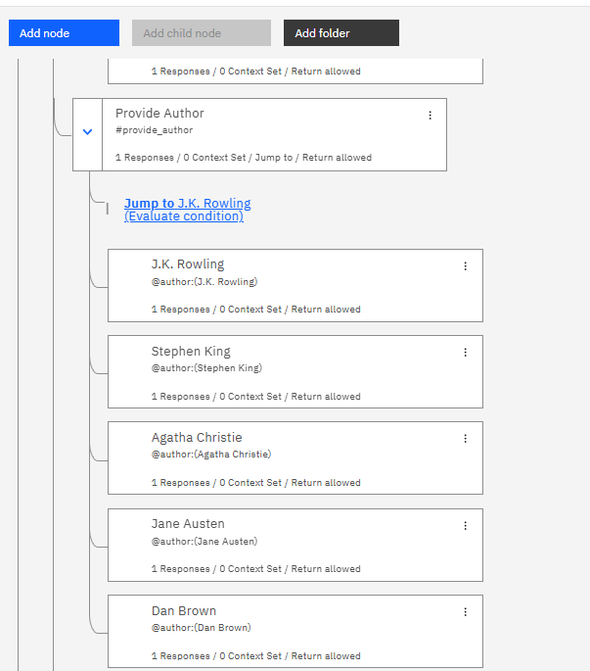

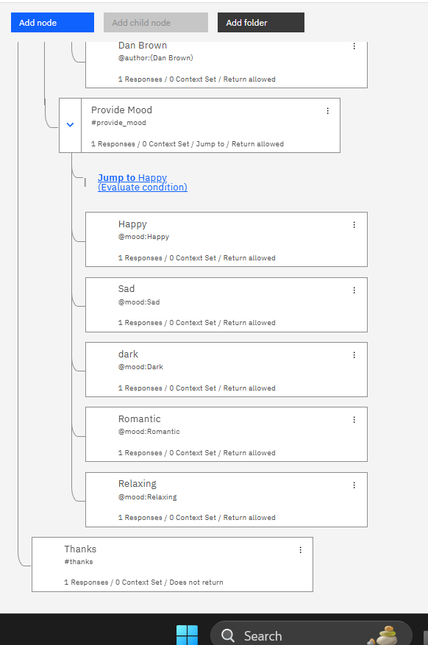

# HOW WEBSITE LOOK

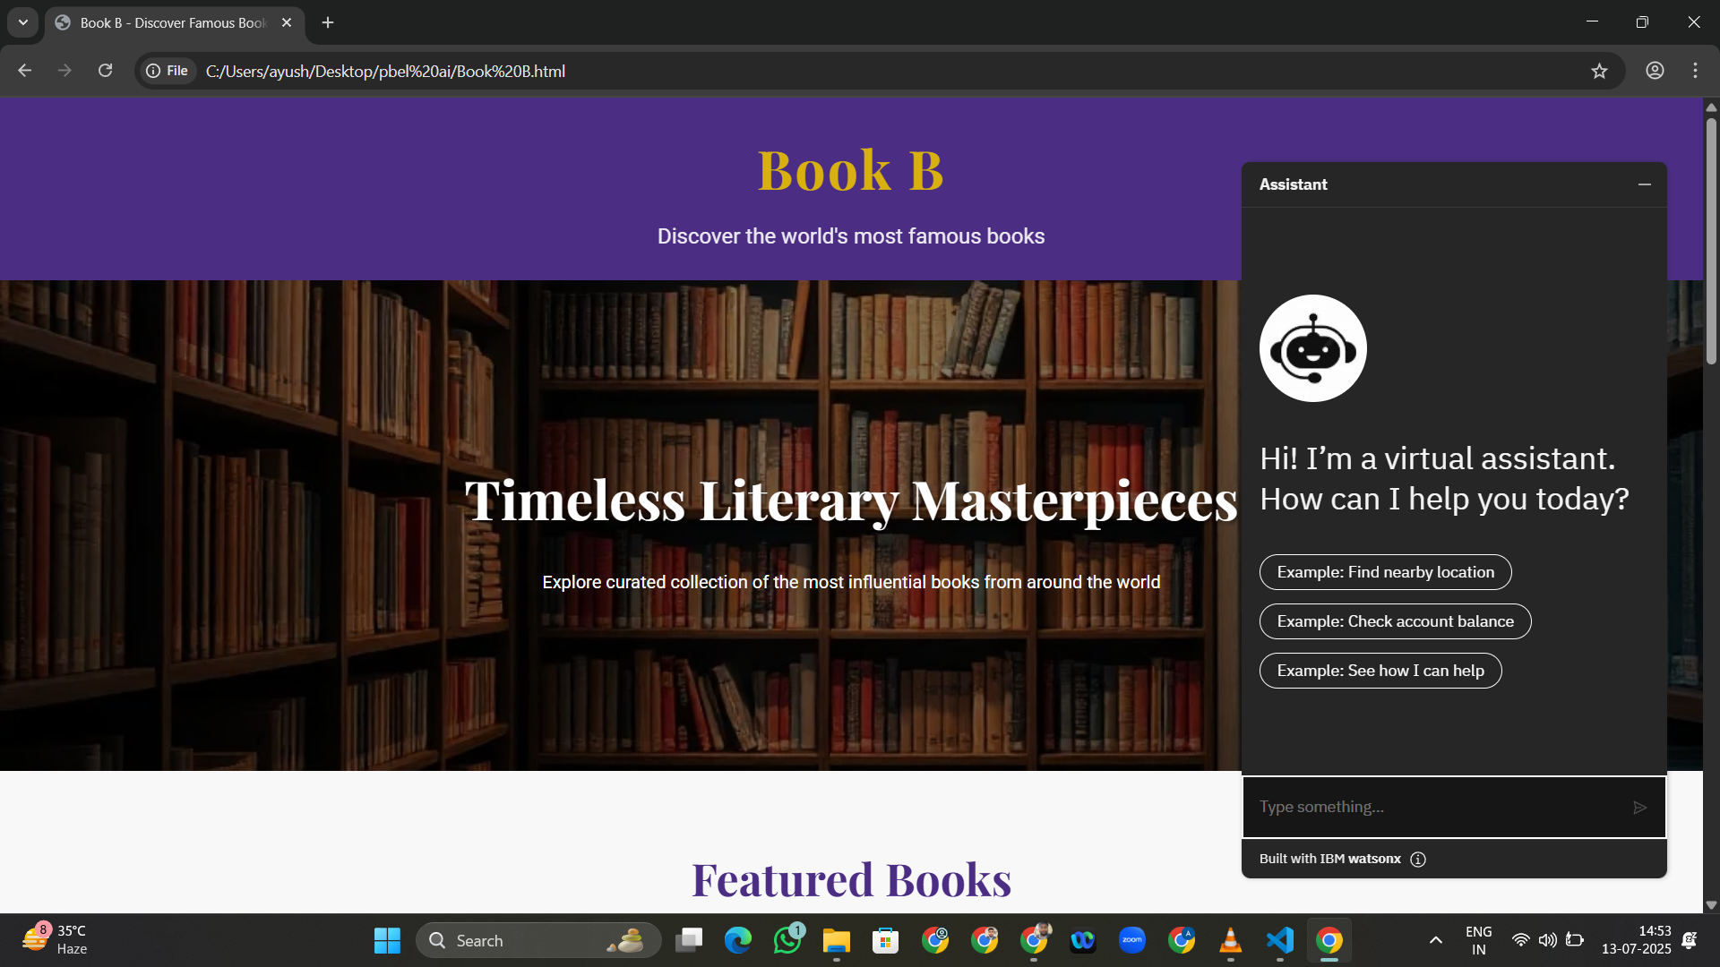

Fig :-- This is the image of how website look after integrated with ibm virtual assistant.

# RESULTS

In this section we see how assistant show result on basis of different input:-

1. On the basis of author:-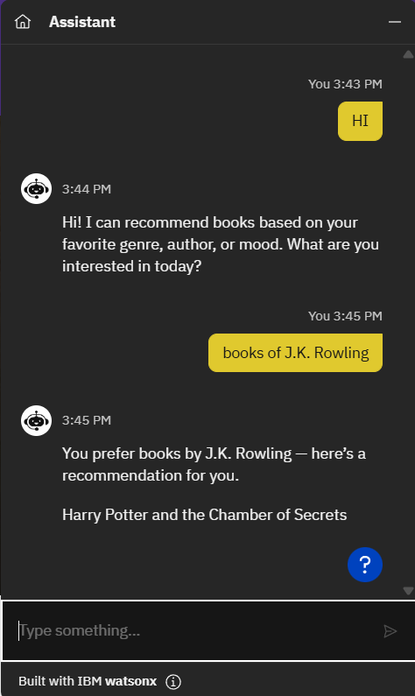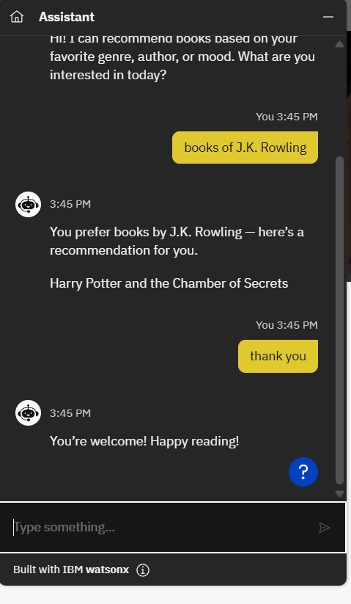
2. On the basis of Mood:-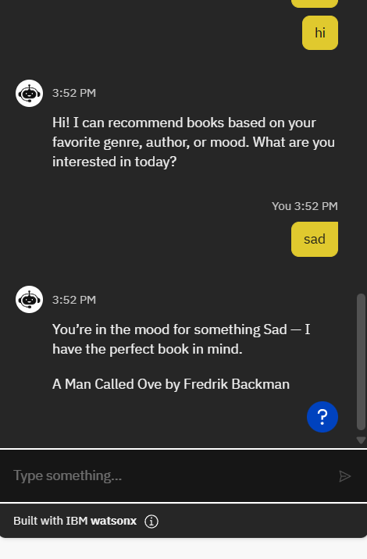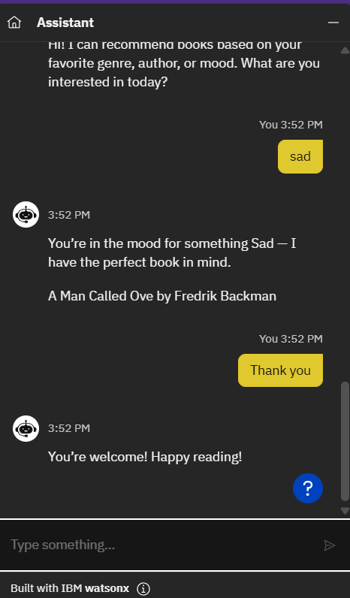

# REFERENCE

1. Image Link:- (Bot Icon)

https://i.ibb.co/fG4g9jHp/OIP-99x99.jpg

1. Website Link:-<file:///C:/Users/ayush/Desktop/pbel%20ai/Book%20B%20Book-Recommendation-Chatbot-using-IBM-Watson-Assistant.html>
2. Some refrence from <https://chatgpt.com/>